**Linear Search**

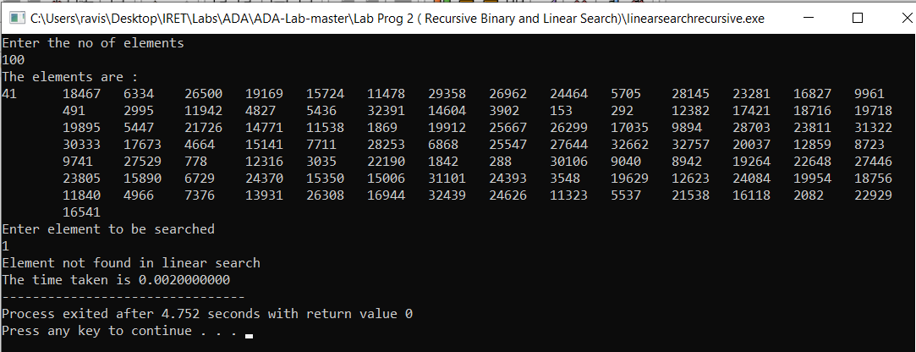

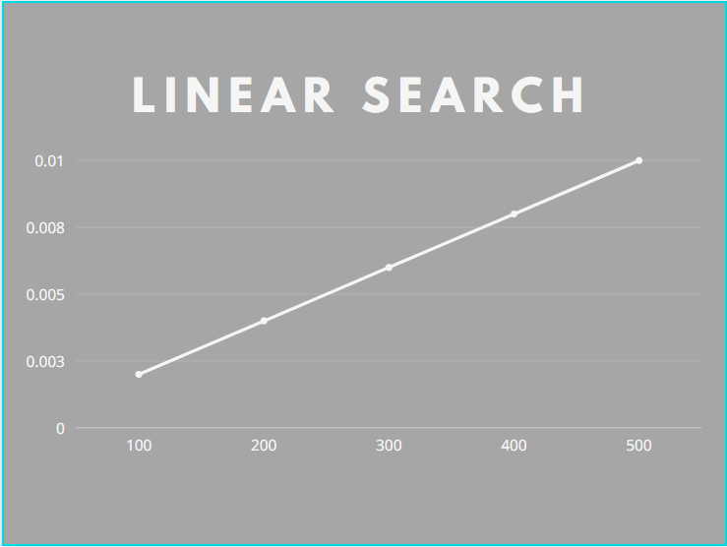

|  |  |
| --- | --- |
| Linear Search  Array size | Time in sec |
| 100 | 0.002 |
| 200 | 0.004 |
| 300 | 0.006 |
| 400 | 0.008 |
| 500 | 0.010 |

**Binary Search**

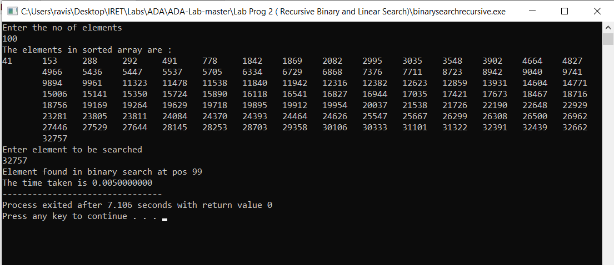

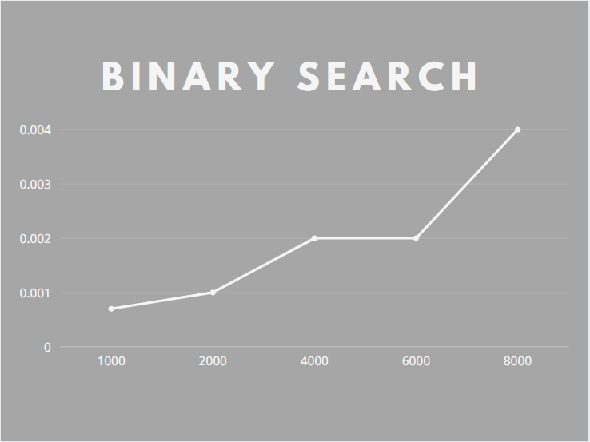

|  |  |
| --- | --- |
| Binary Search  Array size | Time in sec |
| 1000 | 0.0007 |
| 2000 | 0.001 |
| 4000 | 0.002 |
| 6000 | 0.002 |
| 8000 | 0.004 |